4.16.2018

This week leave on autotrader at all times.

Force default trading lot size at 1 lot to see how it happens.

After market:

1. Firmly under SMA
2. Vol up 2-3v, front month at 29v, back month at 24v.
3. Keep building moving average trading tool to hedge.

4.17.2018

MA Issues

1. Consecutive same direction trades (allow for now, 1. space them out exponentially, 2. increase min bar height requirement to reduce frequency of hits)
2. Bar range too small, can’t tell trading direction (solution: min bar range > 10)
3. Direction checking (flip?) (unclear for now)
4. Overnight trading – selling at discount and buying at premium is a disadvantage. (unclear)
5. Persist maSignals across chinamain sessions (maSignals should include all signals from cutoff point until last trade time) (maSignalsPersist calculates all signals from future session open to lastTradeTime)

4/20/18

Weekly review:

Stocks: -23k

Futures: up 22k

Ptf:

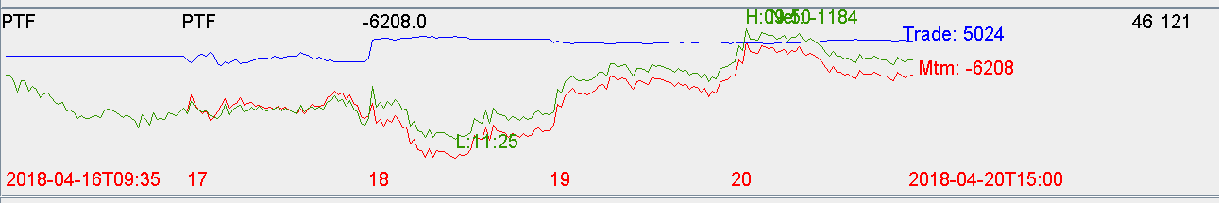

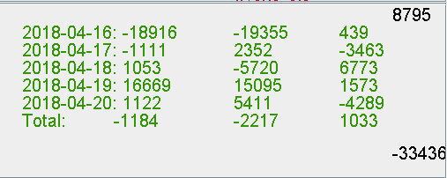

Comments:

Focus on futures hedging going forward.

Automation is making progress.